**Project - 3: Publishing Amazon SNS Messages Privately**

* Step 1: Create a Key Pair

Step 2: Create Resources.

Step 3: Check the Internet Connection for Your Instance.

Step 4: Create an Endpoint.

Step 5: Publish a Message.

Step 6: Verify.

Step 7: Clean Up

* Created key pair name as “VPCE-Tutorial-KeyPair”.

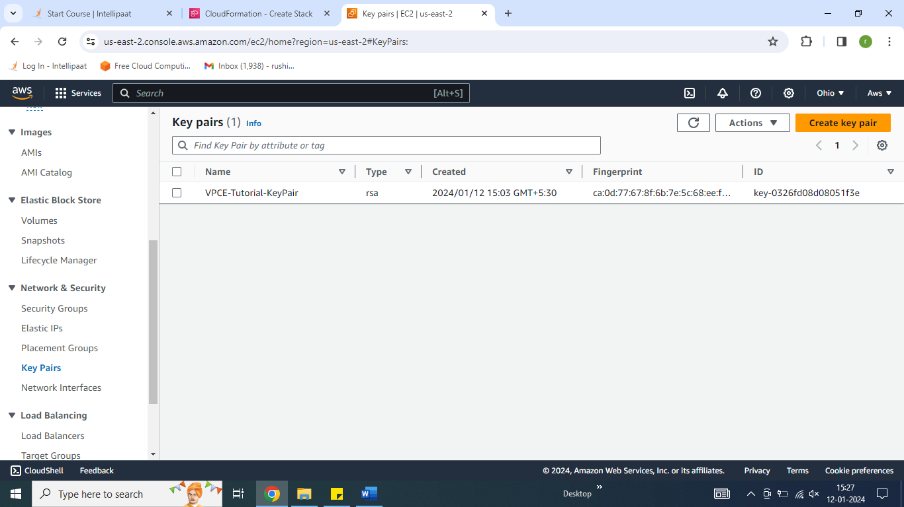

* Creating a stack in CloudFormation and uploading a template.

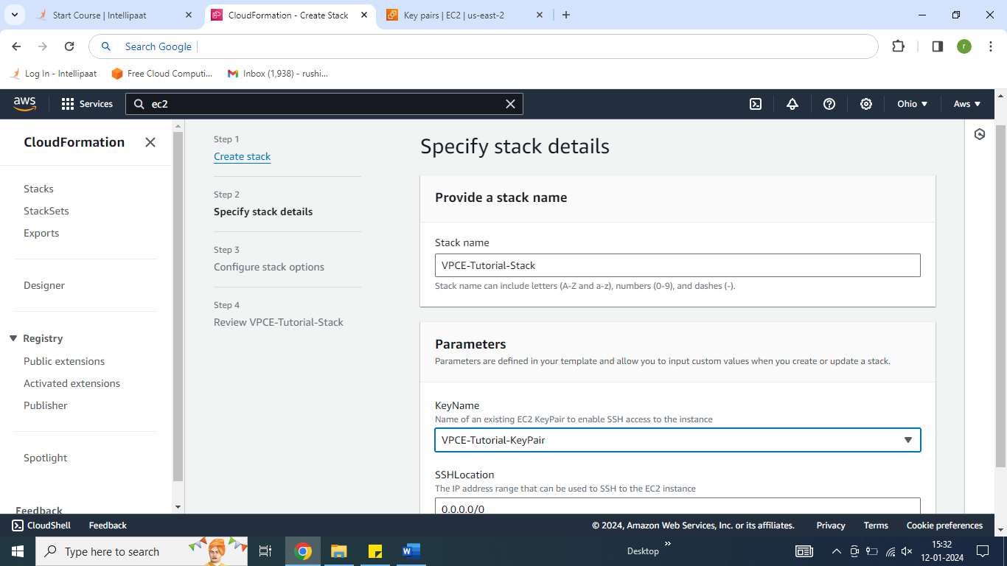

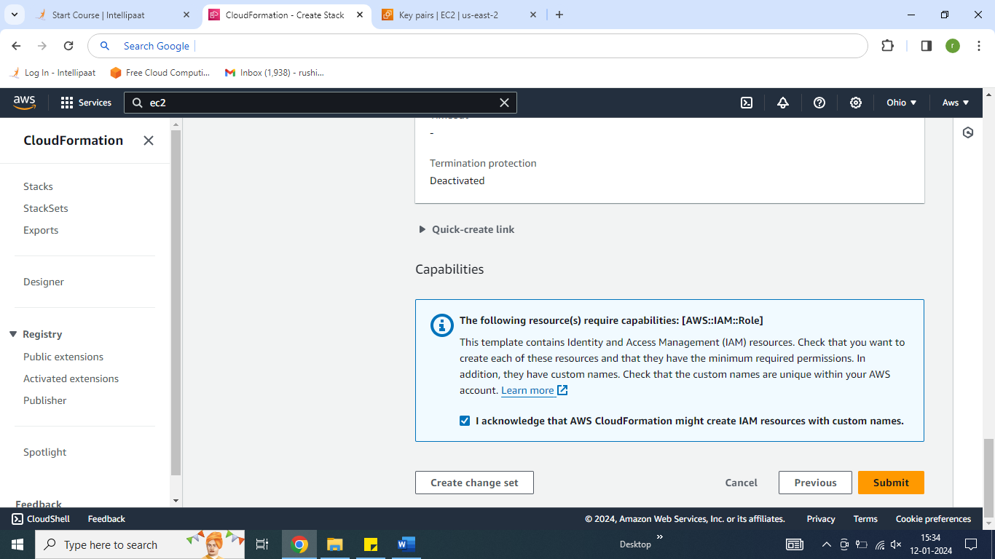

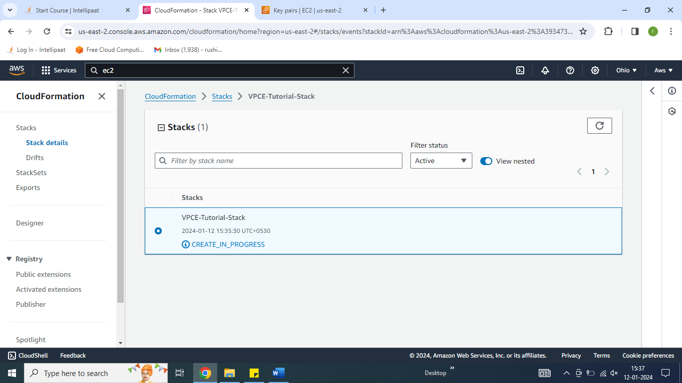

* The AWS CloudFormation Stack created successfully.

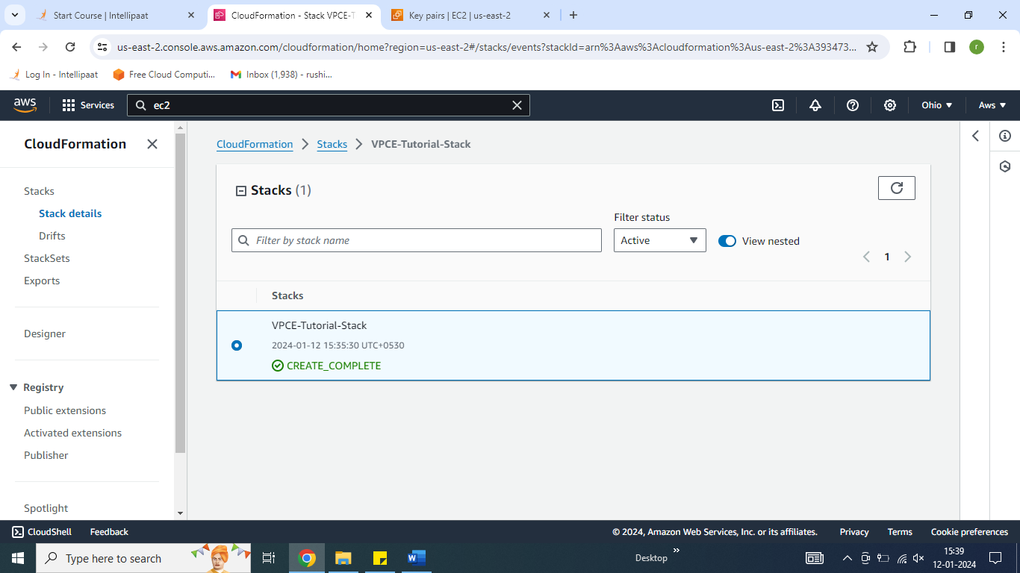

* EC2 created through stack.

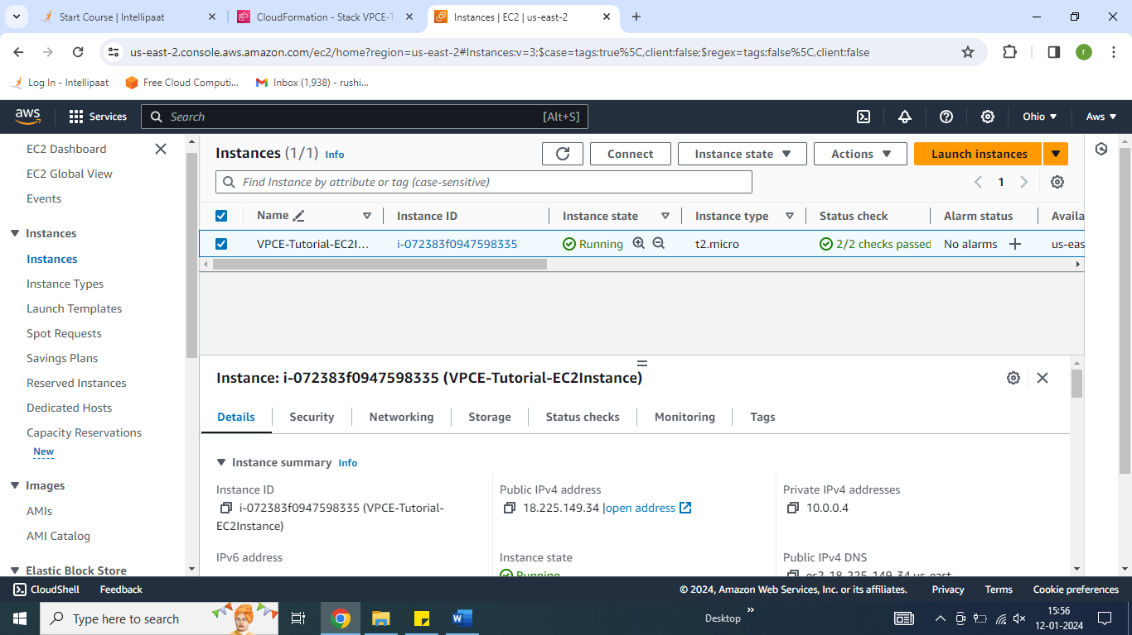

* Ping Amazo.com and it is working.

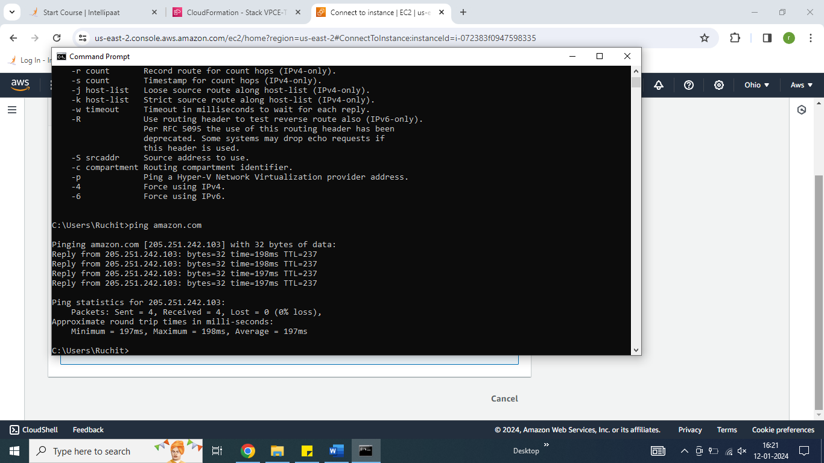

* Now go to **Amazon SNS.** On the Topics page, copy the Amazon Resource Name (ARN) for the topic VPCE- Tutorial-Topic.

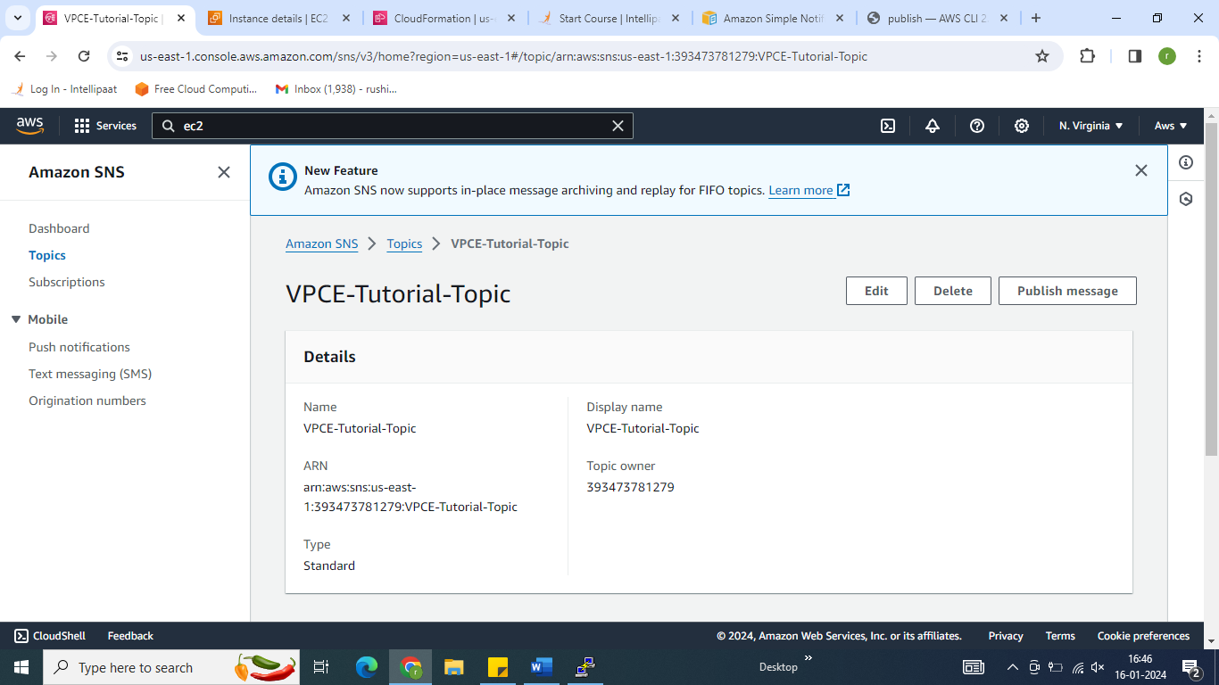

* Attempt to publish a message to the topic but failed.

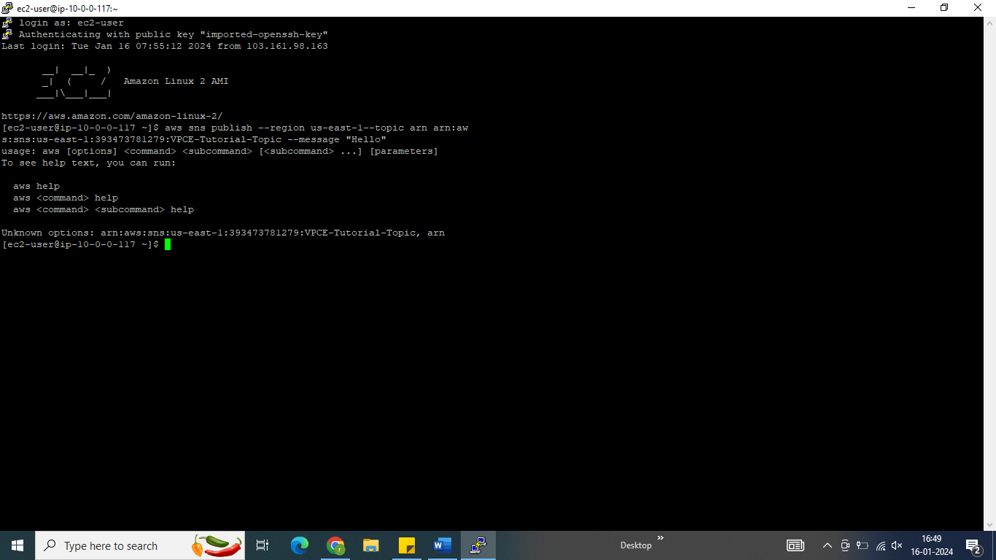

* need to Create an Amazon VPC Endpoint for Amazon SNS.

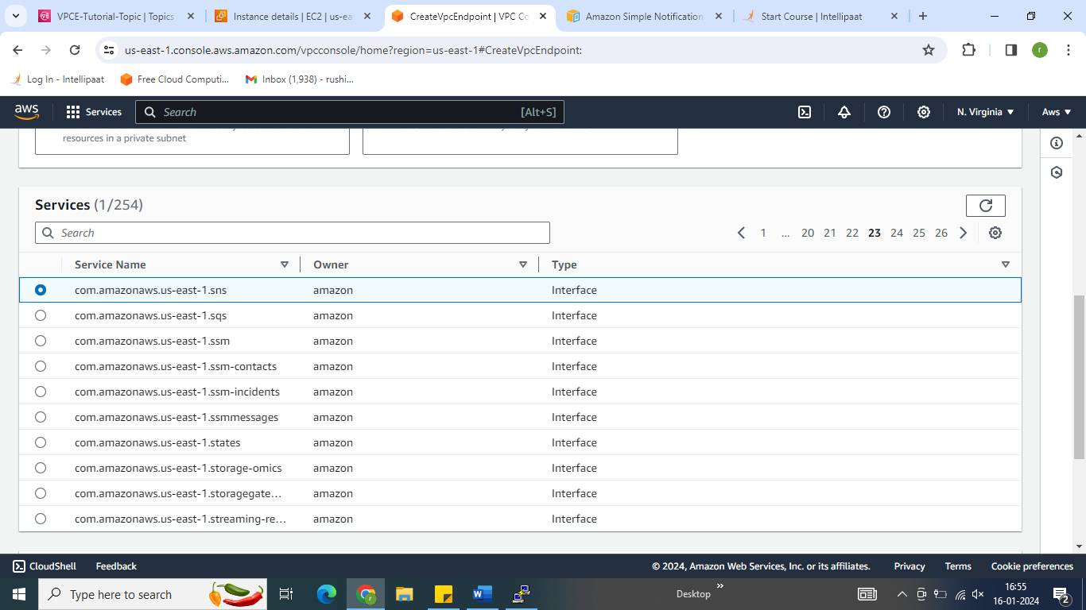

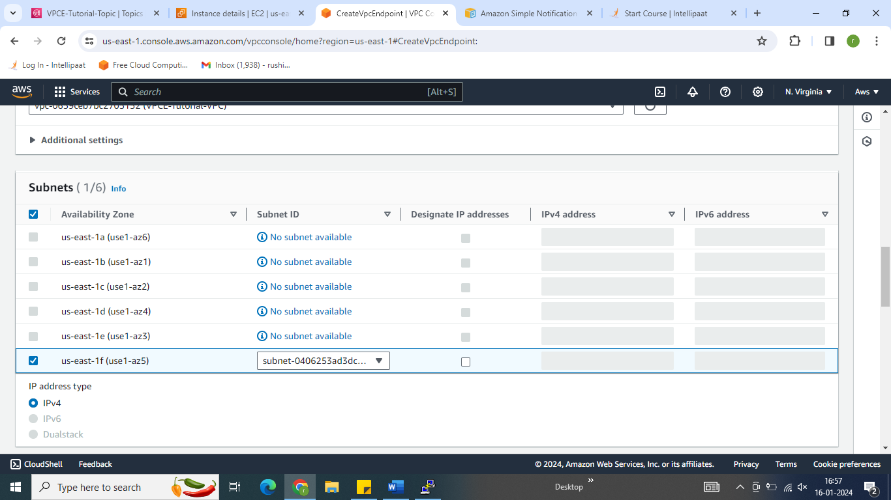

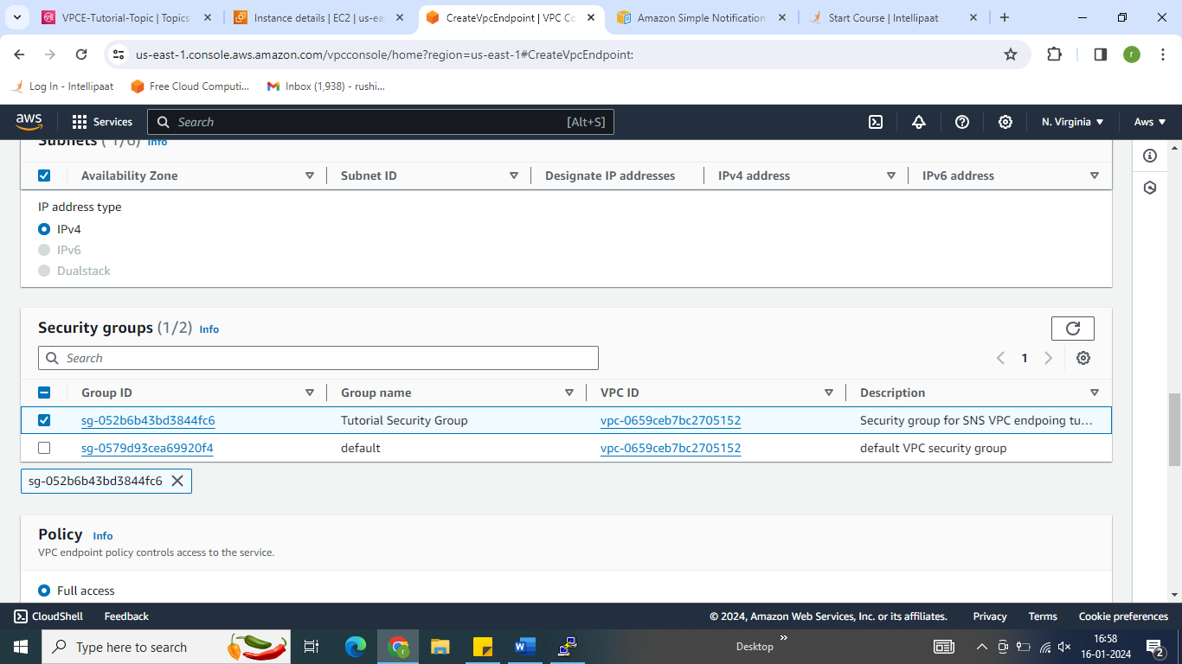

* VPC endpoint created.

